Teams Phone
Handbook

Glossary of Terms 5
Purpose of this document 5
WWU Phone System Overview 6
Migration of WWU’s phone system. 6
How do Phones work at Western? 6
The difference between personal and departmental phone numbers and uses. 6
When should a phone number be a Call Queue instead of a ‘normal’ number? 6
Phone Hardware 7
Headset 7
External Speakers/Microphone 7
Desktop phones 7
Departmental Phone Systems in Teams 8
How do phone queues work? 8
Call Flow 8
Departmental Phone Design 9
Auto Attendant 9
Call Queue 9
What settings can be changed in a departmental Phone Queue configuration? 9
Greetings 9
Call Routing 9
Holidays 10
Hours of Operation 10
Calling ID 10
‘On Hold’ Audio 10
Agent Routing Method 10
Agent Alert Time 11
Presence Based Routing 11
Agent Opt Out 11
Maximum Calls in Queue 11
Maximum Wait Time 11
Departmental phone operations in Teams 11
Teams enabled voice interface 12
Managing settings for your team 13
Managing team members 13
Toggling off the call queue 14
Call queue notifications and call answering 15
Departmental Queue Call Logs and Shared Voicemail 15
Calling out as another phone extension 16
Personal Teams accounts and phone numbers 16
Overview 16
Licensing 16
Answering Calls 17
Making Calls 17
Call Window 18
Keypad 18
People 18
More/Options 18
Microphone mute/unmute 18
Disconnect/Leave/Hang up 19
Other caller icon/video 19
Self icon/video 19
Call Operations 19
Hold 19
Transferring calls 19
Phone Log 20
All Tab (History) 20
Voicemail Tab 22
Speed Dial 23
Contacts 23
Settings 23
General 24
Privacy 24
Notifications 24
Devices 24
Calls 24
Other things to know about Teams and Calls 25
Spam Phone Calls 25
Accessing Teams 25
Appendix 26
1. Call queue call flow diagram 26

Glossary of Terms
PBX – Private Branch Exchange. This server is what used to be the primary home of our phone system. It is very old technology and is no longer supported by any vendor.
Agent – A person (or common area phone) in a call queue that is notified when a call is waiting in the queue to be answered.
Analog – Older technology phones. These devices are not compatible with Teams.
Common Area Phone (CAP) – A desktop VOIP phone that is generally used in areas where multiple people share access to the device and/or where there is not a computer available.
Phone – Unfortunately, this term is a catch all term for many different elements. A ‘phone’ in the most generic sense is a device or bit of software that can dial a number that connects to another device/software to which the dialed number is attached. It can be a physical device, such as a desktop or cell phone, or it can be a piece of software. Teams, for example provides the structure to attach a number to a specific user account, allowing a person or system account to be contacted directly when the number is dialed.
Phone Queue – A generic term used to describe the many configuration and application elements required to make a ‘departmental’ phone number function. It is a shortcut meant to describe a departmental phone number as single entity (even though it consists of many pieces).
Call Queue – This is one component of a departmental phone queue. It is where waiting customers are held, waiting for an agent to answer their call.
Teams – A cloud-based ‘unified communication’ tool, allowing workers to communicate and work together. Our phone system has been almost entirely migrated to this platform.
Team – An organized group of people created in Microsoft Teams for a particular purpose or function, such as a project or phone queue.
Channel – A subgroup of a team, allowing for conversations or functions on a specific topic or purpose. Phone queues function on a voice enabled channel within a given team. There can be multiple voice enabled channels in a team.
VOIP – Voice Over Internet Protocol. In the context of Teams and our phone systems, these phones use more modern technology. Phones with this kind of technology are basically special purpose computers.

Purpose of this document
This handbook is intended to describe usage of Teams for phone purposes. It will describe our WWU’s Teams phone environment, departmental phone queue designs, settings, and basic use of Teams as a phone.
While it is intended to provide some detail of features available, how to use some functions, and generally how our phone system works, it is not intended as an exhaustive user manual on all the functions and uses of Teams. It is primarily for the purpose of helping people understand our Teams phone environment a little better.

WWU Phone System Overview

Migration of WWU’s phone system.
In early 2020 WWU decided to migrate to Teams voice. This was primarily due to the end of life of our PBX system. We could no longer get support for this aged technology. If it failed, our entire phone system would cease to function, resulting in an operational disaster. To prevent that, Telecom began the process of moving phones off the very fragile analog PBX server into a more modern solution.
Of course, this process is not without its challenges. We rely on an increasingly complex arrangement of software and hardware. It involves cloud-based services, special hardware behind the scenes, our already complex network, mini-computer phones, training, expertise in systems which are new to much of the world (and we are a relatively early adopter to Teams Enterprise Voice), and much more.

How do Phones work at Western?
In the simplest terms, a phone is probably a device through which you make and receive phone calls. But the answer to that question is much more complicated in a modern era than it used to be. To start with the lines between what is considered a ‘phone call’ is not clear as it used to be.
Is a phone call a communication between two people? Or potentially more? Can it include video? Must it be from a device you hold in your hand (would a headset or earpiece count)?
Much of what we would consider phone communications in the modern era has nothing in common with what would be considered part the telephone network that used to exist.
Some phones still require what we refer to as ‘analog’ type communication methods, most of which rely on technology that has not been updated in a long time. These phones function similarly to the way they always have on campus and should not require any explanation.
However, almost all the phone configurations on campus have been moved into Teams, and phone numbers in Teams fall into one of two categories – personal and departmental. What is the difference?

The difference between personal and departmental phone numbers and uses.
Personal numbers are the unique phone numbers assigned to each person. Calls to this number are routed directly to the individual’s Teams account. The account is logged in using your Western Login (ending in @wwu.edu) and password. These numbers move with the individual if they move to a different department. If a person searches for you in Teams, then uses a phone icon to call you, they are calling your personal Teams account, and it will leave a voicemail to your personal voicemail space.
Departmental numbers (which were formerly called ‘complex’ numbers) are numbers that do not belong to a single individual. They require more effort to build, have more complicated routing options, and have their own shared voicemails and call queues, which can be monitored by multiple individuals in a shared space. These are numbers that serve as a contact point for department, service, or other purpose.

When should a phone number be a Call Queue instead of a ‘normal’ number?
If the number has any of the following features, it should be a call queue –
- The phone number is publicly published (on the web or in print).
- If the phone number must stay in the department if the person leaves the department or WWU.
- It is a customer facing, ‘purpose’ based phone extension exclusively for people to contact for a work-related reason.
- Multiple people need to monitor the phone number, answer voicemails, etc.
Think of it like this, your personal extension reaches you directly, while a departmental number is tied to the work of the department, rather than you as an individual.

Phone Hardware
As we touched on a bit earlier, the definition of a phone is not the same as it once was. A phone is a combination of software and hardware. For the purposes of Teams there are a couple of possibilities.
Because every person has different preferences, you should evaluate your needs before deciding what hardware you need.

Headset
This is by far the best option for working with phone systems in Teams. There are a wide variety of options, features, form factors, and prices. Headsets provide some conversation privacy and clear audio. Some common features can include noise cancelling, built in microphones (highly recommended), comfort designed earpieces, wireless/Bluetooth (highly recommended), etc. Speak to your IT support if you need assistance with selecting a headset for your needs.
Teams has a feature that allows a secondary ringer. This is good, since if you are not wearing your headset/headphones all the time, another speaker (external) can be selected play the audio of the call notification whenever you receive a call.

External Speakers/Microphone
External speakers and external microphone can also serve as a phone device. It is less private, more difficult to use (since the microphone and speakers must be positioned properly, and there is some possibility of feedback issues). There are also a wide range of options.

Desktop phones
Desktop phones are generally not an option. Most of our old analog devices are not functional, and while there are some desktop phones still active and being used, Telecom is not directly supporting them except for purposes of emergency, disability accommodation, or common area usage.
The policy for desktop phone placement is to minimize complexity. Modern desktop phones are complicated, expensive, minicomputers that must be maintained and replaced if not functional. They add another layer, and potential point of failure, to phone communication, so it is Telecom’s recommendation, and WWU’s policy, to use a headset if a phone device is intended for individual use.

Departmental Phone Systems in Teams

How do phone queues work?
Well, it is complicated. There are several points of decision, and points where a caller might hear a message from the system. When a caller dials the number, and it routes to our system, they could possibly encounter a menu, a greeting, or go immediately to a call queue. There can be different handling of hours of operation, holidays, and messages. Most phone queues are configured to allow a caller to leave a voicemail, but some do not.
Additionally, for those departments with shared voicemail, that voicemail is accessed through the voice enabled channel in Teams for the given call queue.

Call Flow
This is a flowchart of how ‘call flow’ can work in a typical departmental phone queue configuration. While this is not 100% accurate to call flow, you can see there are 4 different areas for different kinds of greetings (3 of which route to voicemail in this example). See Appendix for larger scale version of call flow diagram.
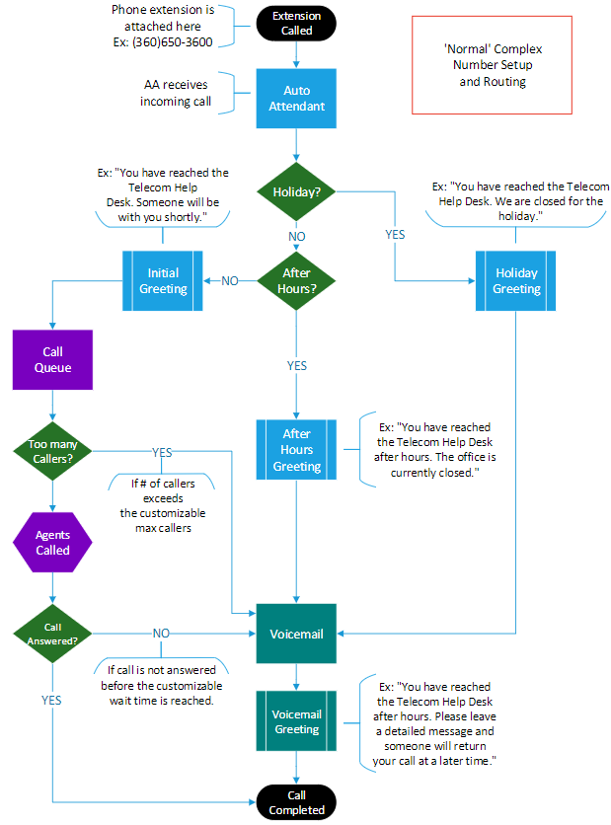
Figure 1. Call queue call flow
So, an unanswered call during open hours goes like this: Customer calls >> Initial greeting >> Call moved to Call Queue >> Agents notified >> Call wait time exceeded >> Voicemail greeting >> Call moved to voicemail for customer to leave message.
While a call during closed hours will go like this: Customer calls >> Initial Greeting >> After hours voicemail greeting >> Call moved to voicemail for customer to leave message.

Departmental Phone Design
It would be impossible to explain the extent of the possibilities for customizing the design of a departmental phone configuration. Any given number can have a menu, multiple queues, dial external numbers, have multiple phone queues, play messages, and route to voicemail. Strictly speaking not everything is possible, but we have yet to encounter a design that was not possible to do. There are some restrictions within the system for minimum/maximum times and not all features are available in all locations.
For most departmental phone designs, there are two primary pieces (there can be multiple of each in a design) that get configured to make most phone numbers operate; the Auto Attendant and the Call Queue.

Auto Attendant
This part of the phone configuration is (usually) where we attach the phone number. It contains the initial greeting and has all the decision points for where the call will go once it is received. If you have a menu, holidays, or after hours, this is the location where all those settings are controlled. For most departmental phones, it will route a customer call immediately to a call queue.

Call Queue
This part of the phone configuration is where all the aspects of a customer call are configured. What agents answer the phone, how long the caller waits, maximum number of calls, and what to do when the limits are exceeded.

What settings can be changed in a departmental Phone Queue configuration?
There are a variety of settings that can be changed in a departmental call queue setup. But first we should make note that most settings still must be modified by Telecom (or other authorized Teams administrator – of which there are very few).
With that in mind – here is a link to the Teams Jira ticket page –
https://wwuhelp.atlassian.net/servicedesk/customer/portal/1/group/60

Greetings
As you can see in the diagram on page 5 there are several places where greetings may occur.
There is an initial greeting, which is we generally use to greet the caller and identify the department (which helps for wrong numbers).
The other greetings exist at certain call routing points (explained in the next section). Generally, these greetings are used as a transition into voicemail, or an informational message to the caller. They can occur at any point where a call routing decision is made.

Call Routing
One of the primary decisions that must be made is what to do with a call at certain points. Since call queue design can be complicated, our example here is for a typical configuration. At each of these points, a greeting can be provided to the caller to provide information.
For example, if you are routing to voicemail, you will want to inform the caller they are being routed to voicemail, and any other information you would like to provide a caller whose call was not answered by an agent. If your call does not route to voicemail, you may instead wish to ask the caller to call back instead.
There order of the decisions (for a typical configuration) is:
- Holiday
- After Hours
- Maximum number of callers exceeded
- For calls in the queue, maximum caller wait time exceeded
So, when a call comes in, it first checks if it is a holiday, then routes according to the settings. Then it checks to see if it is outside of the hours of operation, and routes accordingly. Then max callers, then for calls in the queue, then max wait time.

Holidays
This is a bit of a misnomer since the dates are customizable. We can customize days (or portions of days) to deliver customized routing and messaging.
We already have a set of holidays configured to match the WWU Official Holidays. So, if you want customized routing based upon those days, let us know and we can add it to your call queue.
Holidays override normal processing of calls.

Hours of Operation
This setting allows for operational hours for a given phone number. It is a single optional routing option based upon the days of the week and hours of the day.
A single auto attendant does not allow for different routing for more than one set of hours. While possible (with multiple Auto Attendants), it would be a more complicated routing setup than a standard configuration. If you have complicated hours of operation needs, please contact Telecom.

Calling ID
This setting allows agents of the call queue to dial out as a specified phone extension. Typically, this will be set to the departmental number, but it is possible to assign multiple numbers in this setting.

‘On Hold’ Audio
This setting is either default hold music or an audio file (which will repeat). We do not really have any call queues that do not use the default music.
The audio file will play on repeat, so be cautious before considering this option, since a repeating audio message may be annoying to callers if the wait time is long.

Agent Routing Method
This setting controls how agents are notified of callers in the call queue.
Attendant – (Default) Notifies all available agents of a waiting call at the same time. NOTE: Even if a call queue notification is declined. This setting will continue to notify the agent on a very short cycle if they are available.
Serial – Notifies agents in a specified order. Unfortunately, this setting is not fully functional in Teams currently, since we have no way to change the order of agents in a team. If this is a setting that is needed, please contact us (there are other viable solutions).
Round Robin – Notifies agents of a waiting call by alternating available agents one at a time based on who took the last call last.
Longest Idle – Notifies agents of a waiting call by notifying available agents one at a time based on the agent who has been idle longest first.

Agent Alert Time
This specifies the total time an agent is notified before moving to the next agent. Minimum: 15 seconds, Maximum 3 minutes. Our default is 20 seconds. NOTE: Not applicable to ‘Attendant’ routing.

Presence Based Routing
Changes whether teams will notify the agents based on their Teams status. With this setting on, agents in a call, meeting, or in ‘Away’ status will not be notified. With it off, the call notification will ignore the status of the agent. Our default is ‘On’. NOTE: ‘Do not disturb’ status prevents call queue notification.

Agent Opt Out
This option prevents agents from being able to toggle off their phone queue. It is not recommended you use this option if any of your agents need to opt out of the call queue, since it is a global setting for the queue.

Maximum Calls in Queue
This limits the total number of callers waiting for an agent to answer. When a call exceeds that limit a call routing option is performed. Our default is 2 callers.

Maximum Wait Time
This limits the total wait time for a caller in the call queue. Minimum: 15 seconds, Maximum 45 minutes, at intervals of 15 seconds. Our default is 1 minute.

Departmental phone operations in Teams
Teams options are accessed by clicking on the dots (ellipses) next to the feature you are trying to change. The dots are found next to your profile, your team, in the call window, etc.

Teams enabled voice interface
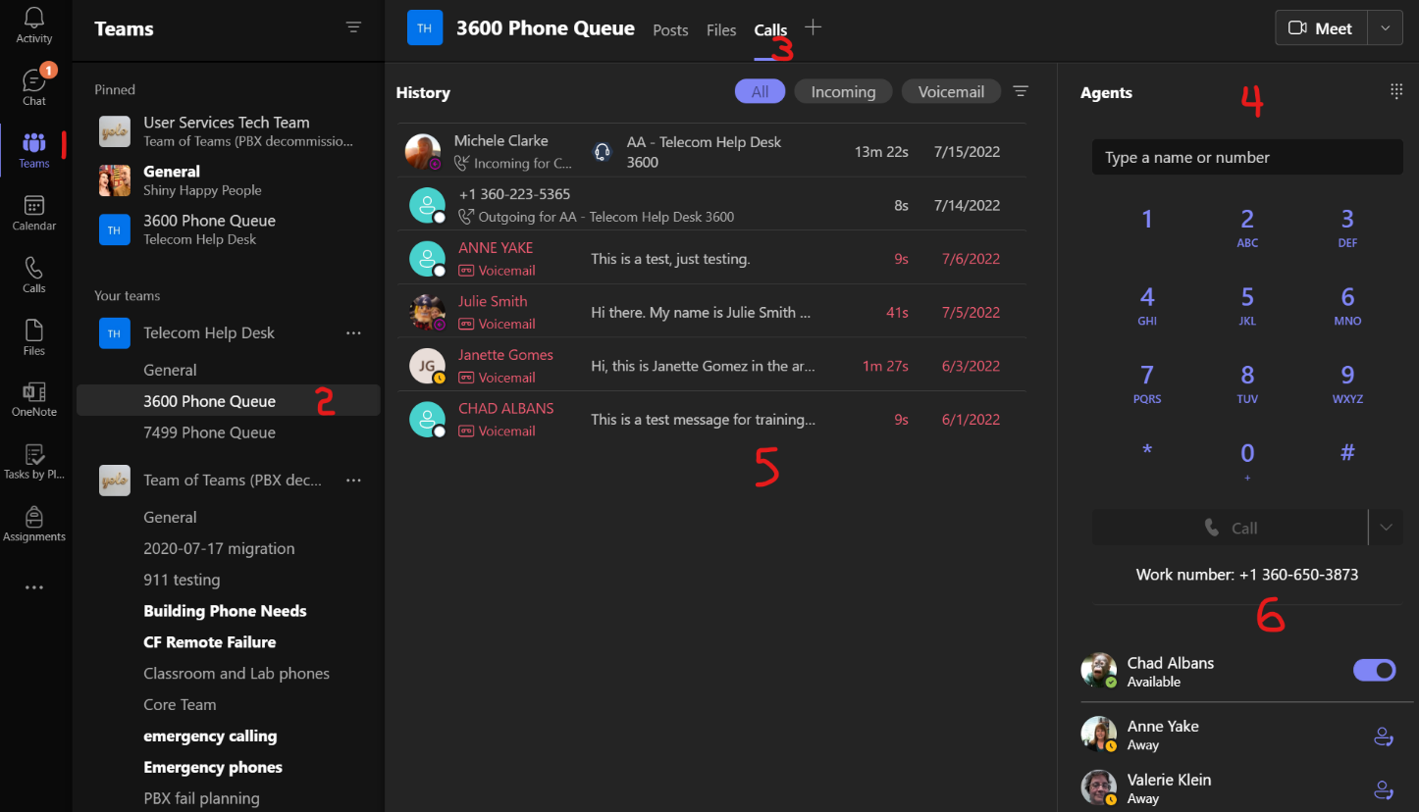
- App bar 4. Dial pad
- Voice enabled channel 5. Call logs
- Calls tab (only exists on voice enabled channel) 6. Agent list

App bar
In the Teams interface, this is where you can find chat conversations, a list of the teams of which you are a member, your calendar, call interface, etc.
For the purposes of Teams voice, we are most concerned with the ‘Teams’ icon on the App bar. Clicking this icon will show a list of available Teams. We highly recommend using the ‘List’ view of the Teams interface. With this view enabled, you will see your teams AND channels in the pane immediately do the right of the App bar.
Otherwise, interfacing with your available channels in Grid view is more difficult since the channels are not shown with that layout.

Voice enabled channel
When you want to select a channel within a team it is found in the left side panel next to the App bar.
Our voice enabled channels for departmental phone queues generally follow the naming convention of (without quotes) ‘#### Phone Queue’, where #### is the last 4-digits of the phone number, so they are easily identifiable. You can ‘Pin’ the channel, so it moves the channel to the top of the Teams/Channels panel.
You need to select the channel (by clicking on it) in order to see the voice enabled features.

Calls tab
This tab only appears if your channel is voice enabled. When you click on the Calls tab you can access a dial pad, the call log, agent list, voicemails, etc.

Dial pad
This is a dial pad which functions essentially the same as the one found in the App bar. From this interface you can call out as the phone number for the departmental queue(s) to which you are assigned.

Agent list
Below the dial pad is the list of agents (all team members and owners), their status in teams and in the queue. This is the easiest way to see the available agents. You can also toggle off your presence in the queue from this location.

Managing settings for your team
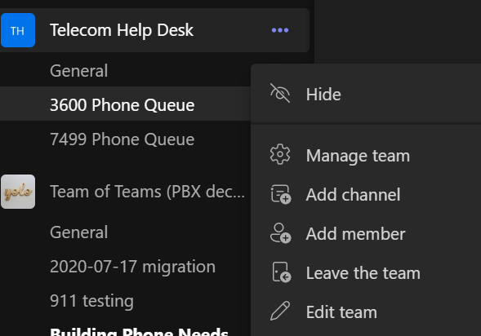
We will not be covering in detail every function you can modify on a team. You have access to team membership and permissions, team pictures, channel management, and other team settings through the ‘Manage Team’ option. For teams with a phone queue, they should remain as private teams.
Additionally, you can rename the team from the ‘Edit Team’ option.
You can also rename a channel by selecting ‘Edit this Channel’ from the channel menu. Please do not rename a voice enabled channel for the phone queue without consulting with Telecom.

Managing team members
Each Team member and owner of a team is counted as an agent and can view voicemails. They will not get notified by the call queue until they have been properly licensed for enterprise voice, which requires Telecom to do. However, staff members or students that are already licensed (such as those that transfer from other departments) can be added without Telecom.
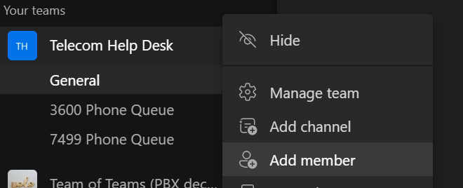
Any owner of the team can add a member once they have been licensed, any owner can add a user through the ‘Manage team’ or ‘Add member’ functions found at with the 3 dots next to the team name.

Select 3 dots, then Add member, then ‘Add member’
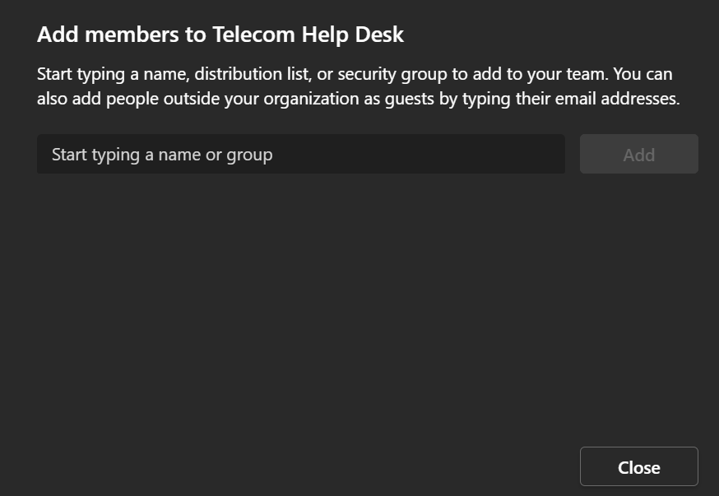
Then add them by typing their name or universal ID and clicking ‘Add’. You can change their status (owner or member) on this screen as well. When finished click ‘Close’. If they are licensed, they will be able to receive notifications from the call queue.
NOTE: It is a good idea to have more than one owner in a team, even if that owner is not an active participant.
See the Licensing section for more information.

Toggling off the call queue
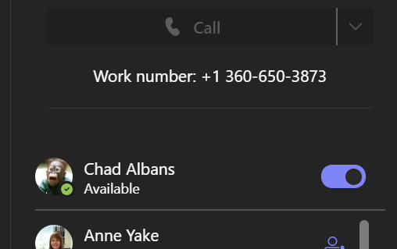
Call Queue participation can be toggled on and off. When off, agents will no longer be notified of calls waiting in the call queue, even if they are logged into Teams. There are two ways to toggle it off.
The first method is directly in the voice enabled channel. Click on the team channel, then the calls tab.
Underneath the dial pad, you will see the list of agents. At the top of that list your name will appear with a toggle button to the right. If the dot is to the right and the graphic is light blue in color, then the queue is on. Click once only since a double click will toggle it off then back on again.
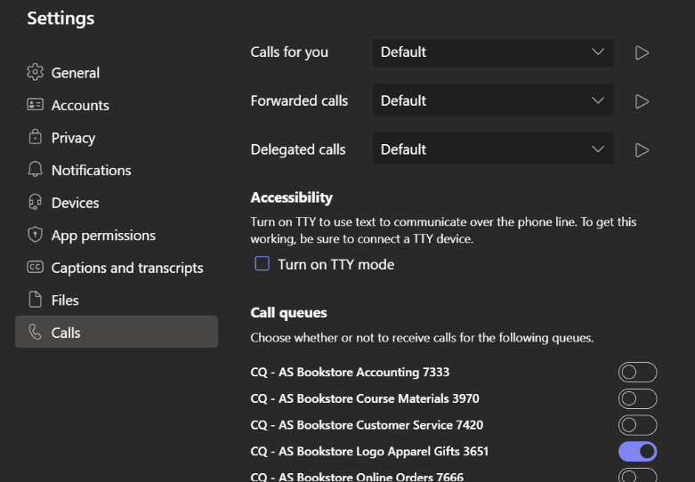
If you have multiple queues, you may find it easier to go through your profile settings. Click on the ellipses next to your profile picture, then click settings. When the settings window opens, click on the calls option. Scroll to the bottom of the window, and you will see the toggle buttons for all your queues. These toggles are the same as in the previous option – single click to toggle and blue means active in the queue.

Call queue notifications and call answering
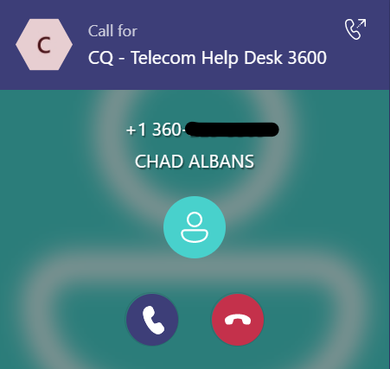
If you are an agent in a call queue, and you have your queue toggled ‘On’ you will receive notifications whenever there is a call in the call queue. If your queue is not set to attendant, you will be notified when it is your turn.
The notification window looks like the one to the right. It identifies the queue as well as the number and identity of the caller. You can accept by clicking the blue icon to the left. You can decline the call by clicking the red icon to the right.
NOTE: If you have attendant routing on your queue, it will continue to notify you as an available agent until the total call wait time is exceeded.

Departmental Queue Call Logs and Shared Voicemail

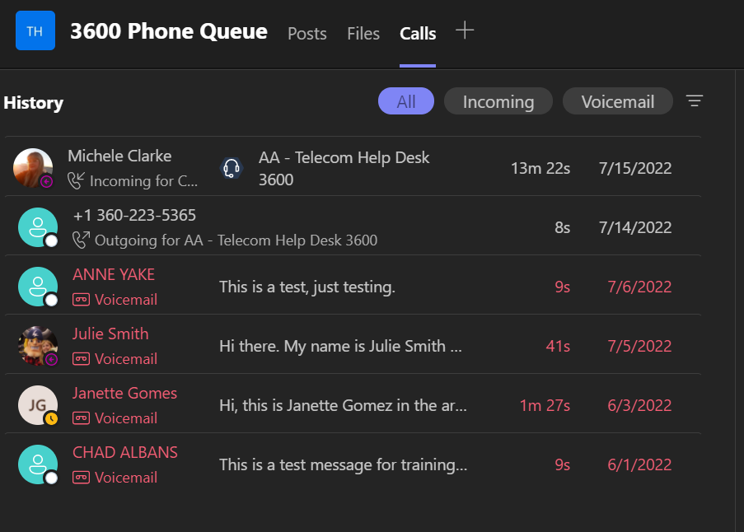
Call log
Most of the window in a voice enabled channel consists of the call log. This will display calls out (from the channel), calls received by an agent, and, if configured, voicemails left by callers.
There are 3 tabs – ‘All’, ‘Incoming’ and ‘Voicemail’. They are self-explanatory, except that ‘All’ should contain outgoing calls made from the call queue as well.
The interface looks like the one shown here, with time information appearing for calls from the same day.

Voicemails
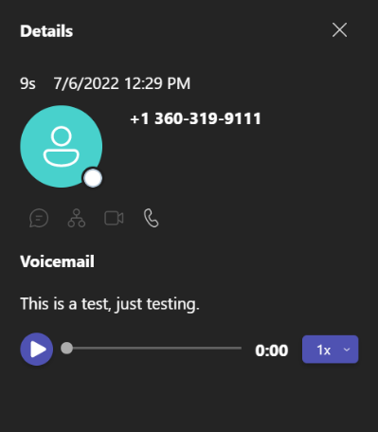
Voicemails appear in the ‘Voicemail’ and ‘All’ tabs in the call log. They are red in color and can be opened by clicking on the entry corresponding to the voicemail you wish to view. After that, the dial pad will be replaced by the voicemail dialogue. Here you can see the details of the voicemail including the date, time, caller ID info, phone number, etc.
By default, we have transcription enabled for voicemail. You can read it the transcription or play the audio or change the playback speed from this dialogue.
NOTE: Clicking the phone icon to return a call uses your personal teams phone extension. It does not default to the departmental extension.

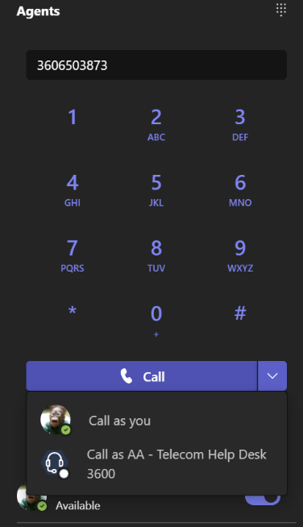
Calling out as another phone extension
Under the calls tab, where you see the dial pad, if you begin typing a number The ‘greyed out’ call button be enabled, which is indicated by turning blue. To the right of the button there is a dropdown arrow that allows you to select your outgoing caller ID. For departmental extensions, this number will begin with ‘AA – ‘ or ‘CQ – ‘ followed by the designation (in this example ‘Telecom Help Desk’), then the 4-digit extension. Caller IDs will show the full 10-digit phone number of the departmental number if you select it as your dial out.
Selecting the extension will immediately begin the phone call, so do not select the dropdown until the number is fully typed/copied in the phone number field at the top of the dial pad.
NOTE: The default option for any phone icon or call back prompts in the call log will be your personal Teams number, so ensure you use the dropdown dialogue if you want to call out as the departmental number. Additionally, most students do not have personal phone extensions, so this option is the best way for them to dial off campus without issue. We have seen numbers marked as ‘unknown’ automatically blocked by the phone carrier or by a setting of the person receiving the call.
NOTE: You cannot use this keypad to interact with a phone menu on a phone call. You must use the keypad in the call window (covered later).
TIP: You can copy the phone number from a call or voicemail by highlighting the number and right clicking (or the keyboard shortcut CTRL+C). The copied number can be pasted in the dial pad.
BONUS TIP: Your ‘main’ dial pad on the Teams App Bar should have all the numbers for all the departments for which you are an agent. This might be faster if you must call out as multiple lines within a short period of time.

Personal Teams accounts and phone numbers

Overview
In addition to departmental phone queues, each non-student employee of Western receives a phone number that is tied directly to their own Teams account, so they can be reached from anywhere directly by dialing this number (which is accessible from off campus if the number is known).
When people search your name in Teams, they are interacting with your personal Teams account. They are chatting with you directly, when someone calls your number or contacts you with the phone icon in Teams, they are doing the same. Voicemails left this way go to your account and are not accessible to anyone else.
All screenshots and discussion are provided based on the desktop version of Teams (web and app versions operate similarly but have a variety of small differences).

Licensing
Teams chat and many other features can be used without any additional licensing. Even phone calls to other employees within Teams is possible with a standard license.
However, to make or receive calls to/from outside of Teams and answer calls as an agent in a call queue, you must have Enterprise Voice. By default, all non-student employees of WWU are entitled to full license (which includes some Office 365 apps as well as Teams Enterprise Voice) without additional cost.
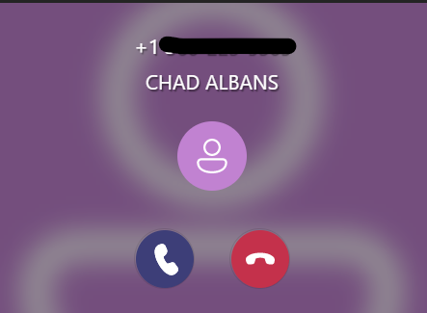
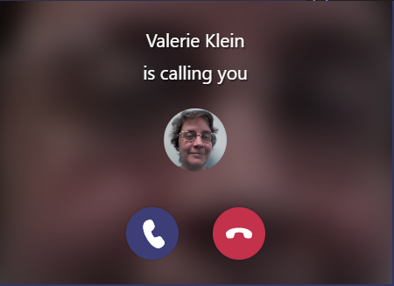
Students, however, require a nominal fee to be able to participate as an agent in a call queue or to make calls off campus (or have a personal phone number – though most students are not assigned a personal number).
Figure 3. External call
Figure 2. Internal call

Answering Calls
An incoming call is indicated with a pop-up window and an audio chime. The two samples shown here are an internal call and an external call, respectively.
It indicates the identity of the caller. You can accept by clicking the blue icon to the left. You can decline the call by clicking the red icon to the right. It will ring until the max caller wait time is exceeded.

Making Calls
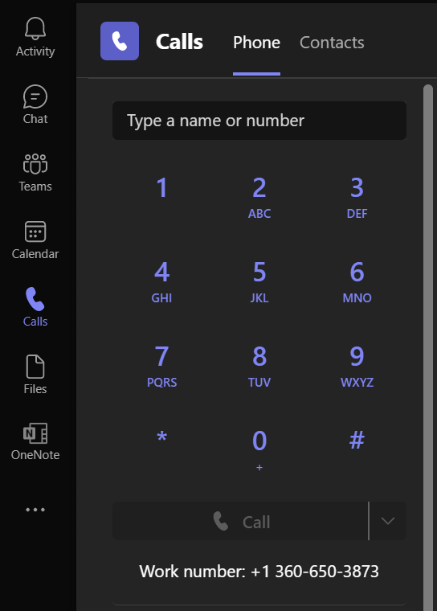
To make a phone call in Teams you can click on the ‘Calls’ icon (an old fashioned phone handset) in the App bar. After clicking you should see a dial pad, since the default tab in this section will be ‘Phone’.
From here you can type the full 10 digit number to dial a number off campus, or the international sequence for international numbers. Alternatively you can type a name of someone at WWU and Teams will search for matching names will appear in a list, from which you can select the person you’d like to call. Once you enter a name or number into the ‘Type a name or number’ field, the ‘Call’ button at the bottom of the dial pad will become enabled.
You no longer need to enter a code for long distance, which is billed to your department, and Teams will dial the number entered without further checks if you click the ‘Call’ button. If you are an agent in call queues, the dropdown arrow will allow you to call out as any call queue accessible to you.
You can also dial out from the dialpad of a phone queue team (covered earlier in this document).
NOTE: You cannot use this dial pad to interact with a phone menu on a phone call. You must use the keypad in the call window (covered in the next section).

Call Window
When you make or answer a call Teams will present a Call Window separate from the Teams client window. From this window you can perform all the call related functions available to you. This window exists ‘per call’ so if you have a second call answered, it will have a window of its own.
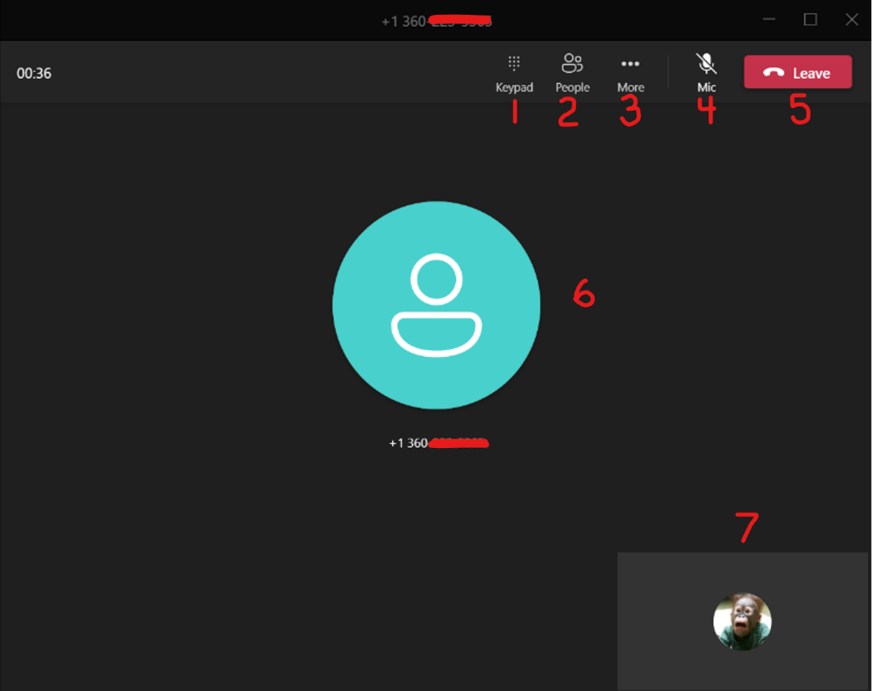

- Keypad 5. Disconnect/Leave/Hang up
- People 6. Other caller icon/video
- More/Options 7. Self icon/video
- Microphone mute/unmute

Keypad
This icon opens the keypad to interact with phone system menus or prompts.

People
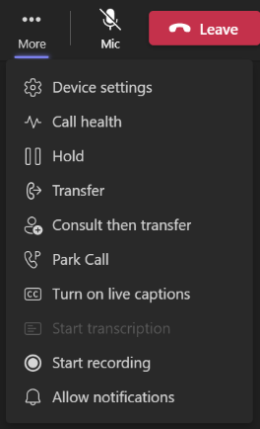
This icon opens the ‘people’ dialogue. You can add people to the call by entering their name or phone number in this dialogue.

More/Options
This option contains most of the call handling options (shown to the right). Some of the options include device settings (headphone/speaker/microphone/camera), hold, transfer options, etc.

Microphone mute/unmute
This button toggles the mute function. If muted, the icon has a line though it and it is greyed out.

Disconnect/Leave/Hang up
Disconnects the call without asking. You can click close the window as well, but you will receive a confirmation prompt to ensure you wish to end the call.

Other caller icon/video
The main section of the call is occupied by the icon representing the other person/people who are in on the call, other than you. If they have video, the video will be displayed in place of the icon.

Self icon/video
The lower right section of the call shows your icon or video if you have a webcam, and it is turned on.
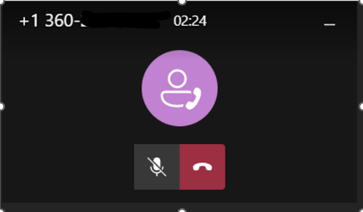
NOTE: You can click away from the call window, and it will reduce the window size to a small window on the lower right of the screen. From here you have only a few controls, such as disconnect, mute microphone/camera, and share desktop.

Call Operations
Call operations are essentially all the things you can do with a call.

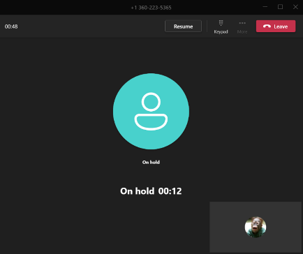
Hold
You can put a caller on hold by selecting the ‘More’ icon (3 dots) and clicking ‘Hold’. This option will mute and play hold music for the person on the other side of the call. You can speak to the caller again by clicking ‘Resume’.

Transferring calls
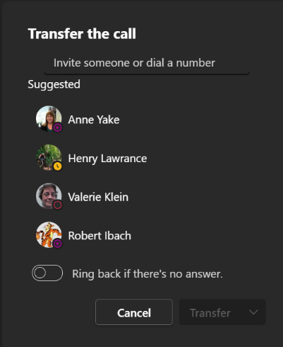
There are several ways to transfer calls within Teams. What you choose will depend on your needs.

Transfer (Cold)
This method is a simple call transfer, it sends the caller to the specified person or number with no interaction with the transfer recipient. This method is generally referred to as a ‘cold’ transfer.
To transfer, click the ‘More’ dots then click ‘Transfer’. The dialogue box to the right will allow you to search for an employee or type in a phone number.
On this option you can select to send the caller back to you if there is no answer, just toggle the ‘Ring back…’ before completing the transfer.
To complete the transfer, click ‘Transfer’. The dropdown allows a transfer directly to a WWU employee’s voicemail, instead of calling them directly.

Transfer With Consult
This is often referred to as a ‘warm’ transfer. It calls the transfer recipient first, allowing you to speak to them prior to a call transfer.
The same dialogue for transferring will appear as with a cold transfer, but the option to ring back does not appear, since you will be contacting the person prior to the transfer. The dropdown box appears if there is more than one contact option. For example, WWU personnel can be contacted via Teams chat instead of calling them directly. If you do not reach the intended recipient, you will need to take the caller off hold to speak to them again.

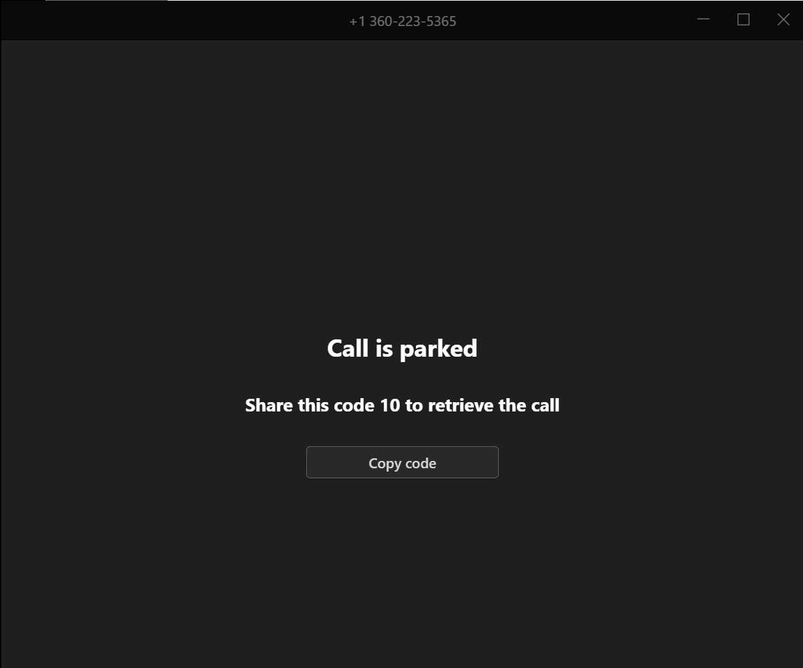
Park
Call parking is a way to transfer a call indirectly. To park, click the ‘More’ dots then click ‘Park’. The dialogue box to the right will allow you to search for an employee or type in a phone number.
Any person at WWU can retrieve the parked call by entering a specific code. Click the options dots then click ‘Park Call’. A dialogue box will appear giving you a code to send to another person in order to retrieve the call. In the example shown here the code is ‘10’.

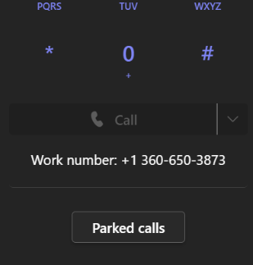

Retrieving a Parked Call
Any WWU employee with a Teams license can retrieve the parked call by clicking on the ‘Parked Calls’ button under the main Dial Pad in Teams.
NOTE: Parked calls cannot be retrieved from a Departmental Phone queue in this way, the ‘Parked Calls’ option does not appear there.

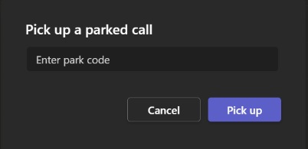
After clicking the button another window will open to prompt you for the code. Enter the code given to you, then click ‘Pick Up’ and it will connect the parked call to you. The code entered here will be given to you by the person who originally parked the call.

Phone Log
After clicking on the ‘Calls’ icon in the App bar, in addition to the Dial Pad, you have a log of the phone calls made and received as well as voicemails. Unviewed calls/voicemails are bolded, and voicemails are shown in red text.

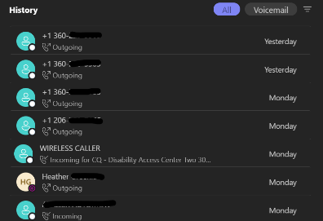
All Tab (History)
The ‘All’ tab shows both voicemails and calls combined. It will show the called or calling number (or possibly name if it is a WWU employee call or their caller ID is present), incoming/outgoing, and the day and/or time the call was made.
If you hover over a call record the options and ‘Call’ icons appear.

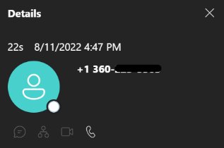
Details
Clicking on a call shows the details to the right of the log. A few more details are shown here, including exact time of the call and duration. You also have icons to chat, make a call, make a video call, or view organization.

Call
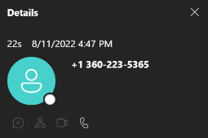
Clicking the call button will call the number/person shown in the log entry.

Options
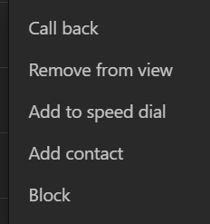
Clicking the 3 dots (ellipses) will show the options menu. You can select Call back, remove from view (hide the entry), Add to speed dial, Add contact, or Block.
If you want to block a number, this is where you do that.

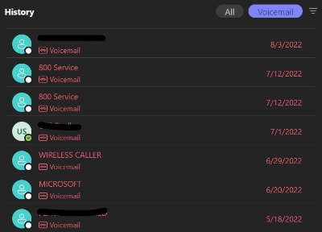

Voicemail Tab
The other tab shown in the logs area is the voicemail tab. It shows only voicemails. All the options for voicemails apply to voicemails shown in the ‘All’ tab.

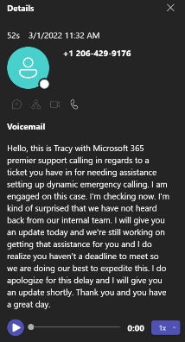
Details
The details tab of the voicemail shows all the same details as a call log, but if you have transcription enabled (which it is by default in our organization) you will also see a text transcript of the call. You can read it the transcription or play the audio or alter the playback speed from this frame.

Options
Voicemail offers two different selections, ‘Mark as unread’ and ‘Delete’ which are both self-explanatory.

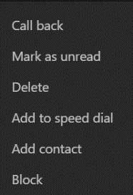
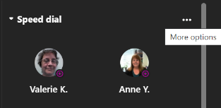
Speed Dial
Speed dial is a ‘quick access’ version of contacts. It allows you to set a few visible contacts on the default page of the Calls dialogue. Hovering your mouse over any section of this area the options dots will appear that allows you to add a contact.
Hovering over a contact shows several contact options (video call, voice call, or phone number options), as well as options dots to remove the contact from Speed Dial.

Contacts
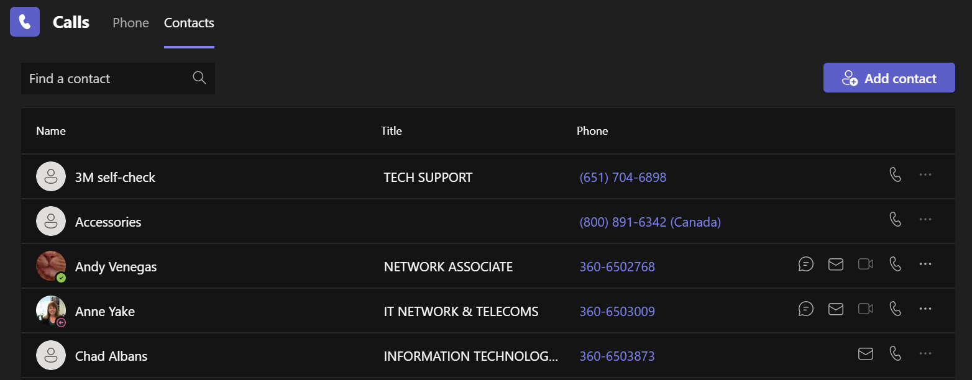
Contacts are found by clicking on the Phone icon in the App bar, then clicking on ‘Contacts’. Contacts are comprised of Outlook and Teams contacts.

This shows the contact Name, Title, Phone, and contact options, as well as the options dots to remove the contact. You can add contacts using the blue ‘Add contact’ button.
NOTE: You cannot remove an Outlook contact through Teams. They must be removed through Outlook.

Settings
There are many phone related settings you can customize within Teams. To get to the options, click the 3 dots next to your profile image at the upper right of your Teams client, then click ‘Settings’ (with a gear icon next to it).
Since this document is only for Teams phone usage, we will skip over ‘Settings’ sections not related to phone specific needs.
For more information about using Teams, Microsoft has some helpful tutorials – https://support.microsoft.com/en-us/office/get-started-with-microsoft-teams-b98d533f-118e-4bae-bf44-3df2470c2b12

General
This tab has general settings for Teams.
Layout
We highly recommend the ‘List’ layout in Teams, as it displays Teams and Channels more efficiently, making voice enabled channels easier to see and access.

Privacy

Blocked Contacts
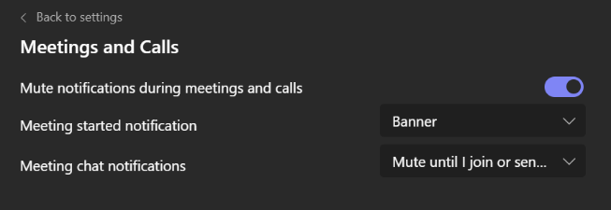
Here you can change the setting to block calls with no caller ID and edit your blocked contacts.

Notifications
Clicking edit on the Meetings and Calls element of this section pulls up some options for call and meeting notifications.
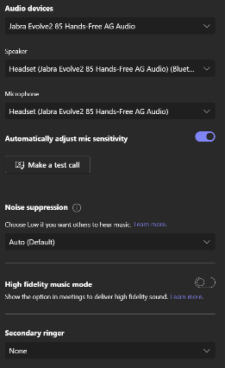

Devices
This tab allows you to modify all the hardware related settings, including your camera, speaker, microphone. If you have external speakers, you can set a secondary ringer to also play the call notification, allowing you to hear a phone call if you do not have your headset on at the time.

Calls
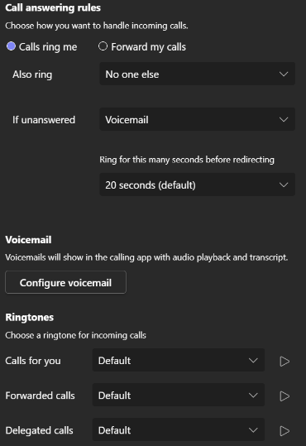
The calls tab is where most of the phone controls are found. You can set your call ring settings, call forwarding, what to do if the call is unanswered, ring time, ringtones, and configure your voicemail settings/recording.
This location also has the toggles for all your call queues.
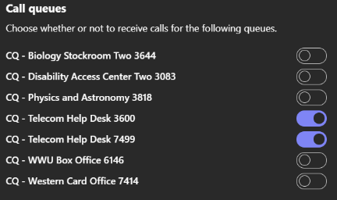

Other things to know about Teams and Calls

Spam Phone Calls
We get several inquiries about ‘Spam’ phone calls or telemarketers. Unfortunately, WWU receives an uncountable number these kinds of calls. There is no reliable way to block all the numbers effectively to eliminate or even reduce this issue. You can block numbers from contacting your personal number by using the ‘Block’ function of a call record, under the phone logs in ‘Calls’ section.

Accessing Teams
The Teams client can be downloaded from the app stores on Android and iPhone. It can also be accessed via a web client only (without an install). The phone and web version offer almost all the features of the Teams desktop client.
NOTE: The voice enabled features are currently unavailable in the phone and web versions of Teams. NOTE: You can currently only access departmental phone queues or shared voicemail through the standard desktop client.

Appendix

Call queue call flow diagram

